NOTTING HILL COLLEGE
PREVENT - Anti radicalisation policy
Date adopted:

SAFEGUARDING STUDENTS WHO ARE VULNERABLE TO EXTREMISM

1) Background
This ‘Preventing Radicalisation Policy’ is part of our commitment to keeping children safe. Since the ‘Education and Inspections Act 2006’ academic institutions have a duty to promote community cohesion. Over the last few years, global events have led to a growth of extremist viewpoints, including advocacy of violent extremism.

Colleges have an important part to play in both educating children and young people about extremism and recognising when pupils start to become radicalised. In March 2015, new statutory duties were placed on institutions by the Counter Terrorism and Security Act (2015) which means they must work to prevent children being drawn into extremism.

Safeguarding children from all risks of harm is an important part of an institution’s work and protecting them from extremism is one aspect of that.

2) Ethos
At Notting Hill College we ensure that through our school vision, values, rules, diverse studies and teaching we promote tolerance and respect for all cultures, faiths and lifestyles. The management also ensures that this ethos is reflected and implemented effectively in school policy and practice and that there are effective risk assessments in place to safeguard and promote students’ welfare.

We have a duty to prepare our students for life outside the college, potentially within the United Kingdom, and to keep them safe. Pupils who attend our college have the right to learn in safety. We do not tolerate bullying of any kind and will challenge derogatory language and behaviour towards others.

3) Statutory Duties
The duty to prevent children and young people being radicalised is set out in the following documents.
• Counter Terrorism and Security Act (2015)
• Keeping Children Safe in Education (2015)
• Prevent Duty Guidance (2015)
• Working Together to Safeguard Children (2015)

4) Non-statutory Guidance
• Promoting fundamental British values as part of SMSC in schools: Departmental advice for maintained schools (DfE 2014)

Notting Hill College values freedom of speech and the expression of beliefs / ideology as fundamental rights underpinning our society’s values. Both students and teachers have the right to speak freely and voice their opinions. However, freedom comes with responsibility and free speech that is designed to manipulate the vulnerable or that leads to violence and harm of others goes against the moral principles in which freedom of speech is valued. Free speech is not an unqualified privilege; it is subject to laws and policies governing equality, human rights, community safety and community cohesion.

The current threat from terrorism in the United Kingdom may include the exploitation of vulnerable people, to involve them in terrorism or in activity in support of terrorism. The normalisation of extreme views may also make children and young people vulnerable to future manipulation and exploitation. Notting Hill College is clear that this exploitation and radicalisation should be viewed as a safeguarding concern.

Notting Hill College seeks to protect children and young people against the messages of all violent extremism. including, but not restricted to, those linked to Islamist ideology, or to Far Right / Neo Nazi / White Supremacist ideology, Irish Nationalist and Loyalist paramilitary groups, and extremist Animal Rights movements.

5) Risk
Senior management and the Designated Safeguarding Lead will assess the level of risk within the college and put actions in place to reduce that risk. Risk assessment may include consideration of the school’s CE curriculum, SEND policy, the use of college premises by external agencies, integration of pupils by gender and SEN, anti-bullying policy and other issues specific to the college’s profile, community and philosophy.

6) Response
Institutions are required to identify a Prevent Single Point of Contact (SPOC) who will be the lead within the organisation for safeguarding in relation to protecting individuals from radicalisation and involvement in terrorism: this will be the Designated Safeguarding Lead.

When any member of staff has concerns that a student may be at risk of radicalisation or involvement in terrorism, they should speak with the SPOC. Numerous factors can contribute to and influence the range of behaviours that are defined as violent extremism, but most young people do not become involved in extremist action. For this reason the appropriate interventions in any particular case may

not have any specific connection to the threat of radicalisation, for example they may address mental health, relationship or drug/alcohol issues.

7) Internet Safety
The internet provides children and young people with access to a wide-range of content, some of which is harmful. Extremists use the internet, including social media, to share their messages. The filtering systems used in our college blocks inappropriate content, including extremist content.

We also filter out social media, such as Facebook. Searches and web addresses are monitored and the ICT technicians will alert senior staff where there are concerns and prevent further access when new sites that are unblocked are found. Where staff, students or visitors find unblocked extremist content they must report it to a senior member of staff.

We are aware that children and young people have access to unfiltered internet when using their mobile phones and staff are alert to the need for vigilance when pupils are using their phones. Students and staff know how to report internet content that is inappropriate or of concern.

8) Staff Training and student awareness
Staff will be given training to help them understand the issues of radicalisation, are able to recognise the signs of vulnerability or radicalisation and know how to refer their concerns. This information also forms part of induction safeguarding training.

Pupils are exposed to the following themes through their time with Notting Hill College:
• Resilience to anti-radicalisation
• Fundamental British values
• Enablement to challenge extremist views
• Awareness of the dangers of social media
• Awareness of “hate” crime

9) Safer Recruitment
We ensure that the staff we appoint to the school are suitable, our recruitment procedures are rigorous and we follow all relevant statutory guidance. Vetting and barring checks are undertaken on relevant people, including backroom staff, senior management and volunteers.

10) Visitors
Visitors to the school are made aware of our safeguarding and child protection policies on arrival at the school and are given information about what to do if they are concerned about any aspect of child welfare.

Visitors who are invited to speak to pupils will be informed about our preventing extremism policy and relevant vetting checks are undertaken. We undertake due diligence to ensure that visiting speakers are appropriate. Speakers will be supervised at all times and will not be allowed to speak to children without a member of staff being present.

Staff must not invite speakers into school without first obtaining permission from senior management.

11) ‘No platform for extremists’
The college is vigilant to the possibility that out-of-hours hire of the school premises may be requested by people wishing to run an extremist event. The college will not accept bookings from individuals or organisations that are extremist in their views.

12) Signs of vulnerability
There are no known definitive indicators that a young person is vulnerable to radicalisation, but there are number of signs that together increase the risk. Signs of vulnerability include:
• underachievement
• being in possession of extremist literature
• poverty
• social exclusion
• traumatic events
• global or national events
• religious conversion
• change in behaviour
• extremist influences
• conflict with family over lifestyle
• confused identify
• victim or witness to race or hate crimes
• rejection by peers, family, social groups or faith

13) Recognising Extremism
Early indicators of radicalisation or extremism may include:
• showing sympathy for extremist causes
• glorifying violence, especially to other faiths or cultures
• making remarks or comments about being at extremist events or rallies outside school
• evidence of possessing illegal or extremist literature
• advocating messages similar to illegal organisations or other extremist groups
• out of character changes in dress, behaviour and peer relationships (but there are also very powerful narratives, programmes and networks that young people can come across online so involvement with particular groups may not be apparent.)
• secretive behaviour
• online searches or sharing extremist messages or social profiles
• intolerance of difference, including faith, culture, gender, race or sexuality
• graffiti, art work or writing that displays extremist themes
• attempts to impose extremist views or practices on others
• verbalising anti-Western or anti-British views
• advocating violence towards others

14) Monitoring and Review
This policy will be monitored by senior management at least annually by receiving a report from the Designated Safeguarding Lead. This is not a statutory policy and will be reviewed at an appropriate time not later than two years after ratification by senior management.

INDICATORS OF VULNERABILITY TO RADICALISATION
Radicalisation refers to the process by which a person comes to support terrorism and forms of extremism leading to terrorism.

Extremism is defined by the Government in the Prevent Strategy as:
Vocal or active opposition to fundamental British values, including democracy, the rule of law, individual liberty and mutual respect and tolerance of different faiths and beliefs. We also include in our definition of extremism calls for the death of members of our armed forces, whether in this country or overseas.

Extremism is defined by the Crown Prosecution Service as:
The demonstration of unacceptable behaviour by using any means or medium to express views which:
• Encourage, justify or glorify terrorist violence in furtherance of particular beliefs;
• Seek to provoke others to terrorist acts;
• Encourage other serious criminal activity or seek to provoke others to serious criminal acts; or
• Foster hatred which might lead to inter-community violence in the UK.

There is no such thing as a “typical extremist”: those who become involved in extremist actions come from a range of backgrounds and experiences, and most individuals, even those who hold radical views, do not become involved in violent extremist activity.

Students may become susceptible to radicalisation through a range of social, personal and environmental factors - it is known that violent extremists exploit vulnerabilities in individuals to drive a wedge between them and their families and communities. It is vital that Notting Hill College (NHC) staff are able to recognise those vulnerabilities.

Indicators of vulnerability include:
• Identity Crisis – the student / pupil is distanced from their cultural / religious heritage and experiences discomfort about their place in society;
• Personal Crisis – the student / pupil may be experiencing family tensions; a sense of isolation; and low self-esteem; they may have dissociated from their existing friendship group and become involved with a new and different group of friends; they may be searching for answers to questions about identity, faith and belonging;
• Personal Circumstances – migration; local community tensions; and events affecting the student’s country or region of origin may contribute to a sense of grievance that is triggered by personal experience of racism or discrimination or aspects of Government policy;
• Unmet Aspirations – the student may have perceptions of injustice; a feeling of failure; rejection of civic life;
• Experiences of Criminality – which may include involvement with criminal groups, imprisonment, and poor resettlement / reintegration;

• Special Educational Need – students may experience difficulties with social interaction, empathy with others, understanding the consequences of their actions and awareness of the motivations of others.

However, this list is not exhaustive, nor does it mean that all young people experiencing the above are at risk of radicalisation for the purposes of violent extremism.

More critical risk factors could include:
• Being in contact with extremist recruiters;
• Accessing violent extremist websites, especially those with a social networking element;
• Possessing or accessing violent extremist literature;
• Using extremist narratives and a global ideology to explain personal disadvantage;
• Justifying the use of violence to solve societal issues;
• Joining or seeking to join extremist organisations; and
• Significant changes to appearance and / or behaviour;
• Experiencing a high level of social isolation resulting in issues of identity crisis and / or personal crisis.

ROLES AND RESPONSIBILITIES OF THE SINGLE POINT OF CONTACT (SPOC)
The SPOC for Notting Hill College is ……………………, who is responsible for:
• Ensuring that staff of the college are aware that you are the SPOC in relation to protecting students from radicalisation and involvement in terrorism;
• Maintaining and applying a good understanding of the relevant guidance in relation to preventing students from becoming involved in terrorism, and protecting them from radicalisation by those who support terrorism or forms of extremism which lead to terrorism;
• Raising awareness about the role and responsibilities of NHC in relation to protecting students from radicalisation and involvement in terrorism;
• Raising awareness within the school about the safeguarding processes relating to protecting students from radicalisation and involvement in terrorism;
• Acting as the first point of contact within the school for case discussions relating to students who may be at risk of radicalisation or involved in terrorism;
• Collating relevant information from in relation to referrals of vulnerable students into the Channel* process;
• attending Channel* meetings as necessary and carrying out any actions as agreed;
• Reporting progress on actions to the Channel* Co-ordinator; and
• Sharing any relevant additional information in a timely manner
* Channel is a multi-agency approach to provide support to individuals who are at risk of being drawn into terrorist related activity. It is led by the Devon and Cornwall Police Counter-Terrorism Unit, and it aims to:

• Establish an effective multi-agency referral and intervention process to identify vulnerable individuals;
• Safeguard individuals who might be vulnerable to being radicalised, so that they are not at risk of being drawn into terrorist-related activity; and
• Provide early intervention to protect and divert people away from the risks they face and reduce vulnerability.

WHAT WE DO WHEN WE ARE CONCERNED
Where risk factors are present but there is no evidence of a particular risk then our DSL /SPOC advises us on preventative work that can be done within the college to engage the student into mainstream activities and social groups. The DSL may well be the person who talks to and has conversations with the student’s family, sharing the college’s concern about the young person’s vulnerability and how the family and school can work together to reduce the risk.

In this situation, depending on how worried we are and what we agree with the parent and the young person (as far as possible) –
• The DSL/SPOC can decide to notify the Multi-Agency Safeguarding Hub (MASH) of the decision so that a strategic overview can be maintained and any themes or common factors can be recognised and ;
• The school will review the situation after taking appropriate action to address the concerns.

The DSL/SPOC will also offer and seek advice about undertaking an early help assessment and/or making a referral to children's social care. The local family support and safeguarding hub can assist us.
If the concerns about the pupil/student are significant and meet the additional needs/complex need criteria, they will be referred to the MASH. This includes concerns about a child/young person who is affected by the behaviour of a parent or other adult in their household.

If deemed necessary, serious incidents will be discussed and referred to the Prevent Team at Greater Manchester Police.

Prevent and Channel
Process map for reporting a concern of a vulnerable individual.
It is important for you as a member of staff to know where to go if you have a concern that someone may be on the route to radicalisation. Below is a flow chart which aims to show the process as to which you can follow:
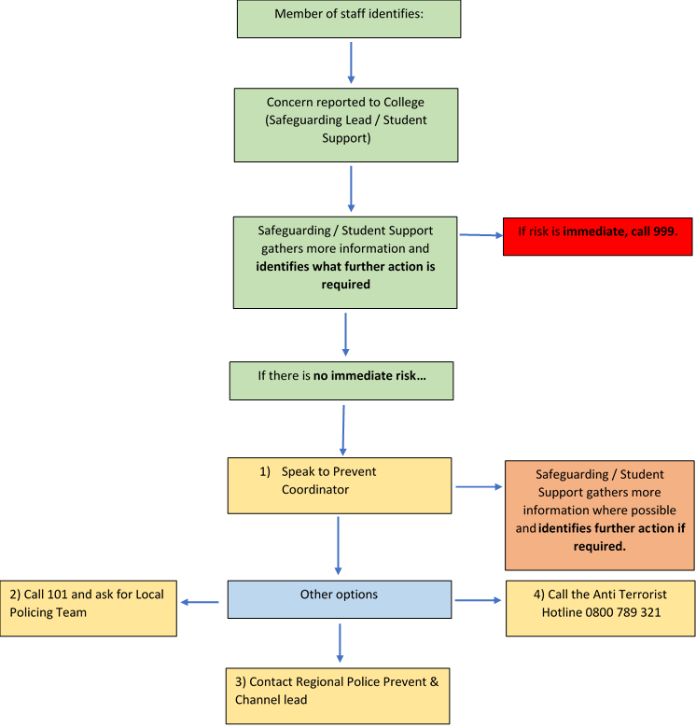

Once a referral has been made and enters the Channel process, the below process map illustrates what happens next.
Further information gathering with your institution and other key agencies that the individual is involved with. Are there shared concerns between partners? Is there a vulnerability to radicalisation?
Police will organise a Multi-Agency Channel meeting which will be made of key partners. The meeting will be chaired by your Local Authority.
Implement support plan depending on level of risk.
If it is deemed there is low risk –further action within normal support. Key agency progresses with further monitoring.
It is important to
remember that consent is gained with the individual to be part of Channel support and intervention.
Regularly review process – Channel Panel members work together to review progress and reduce risks.
The individual will exit the Channel process when all partner agencies feel that the vulnerability to radicalisation has been completely removed or significantly lessened.
Once a referral has exited the process, it will be reviewed at 6 and 12
months. If concerns remain, the individual can be re-referred.
YES
NO

